Segment Intersection

Definition
# Source: AI Source: Provided by: [Data Path: Persons Table -> ID Column: 1, Name_En Column: Motasem Essam] -> From: [ChatGPT] on [7/25/2026]
Segment Intersection is a type of geometric intersection that occurs when two or more line segments share one or more common points.
The most common case is when two line segments cross at exactly one point.
For example, if line segments $\overline{AB}$ and $\overline{CD}$ intersect at $P$:
$$\boxed{\overline{AB}∩\overline{CD}=\{P\}}$$
The point (P) is called the intersection point.
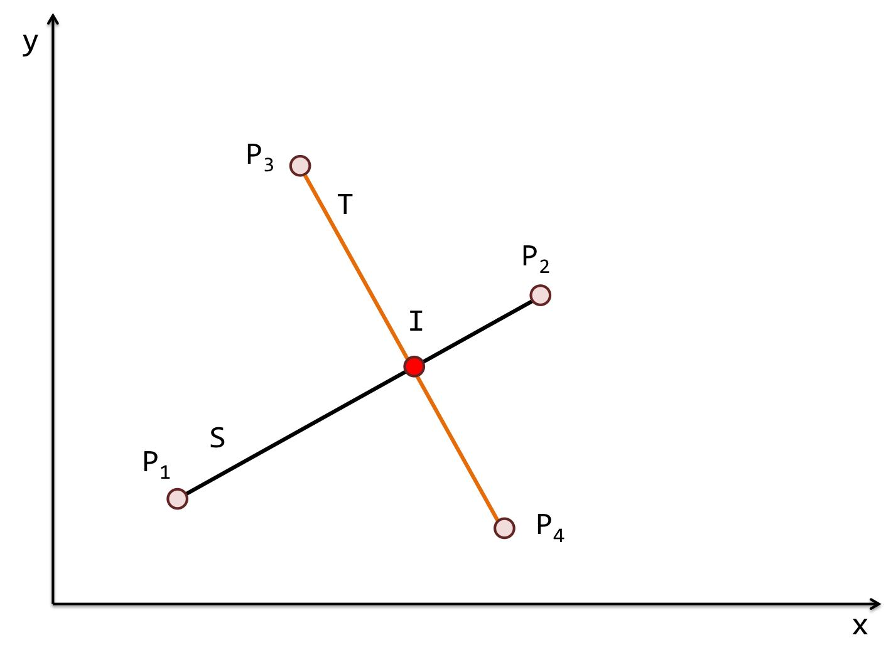
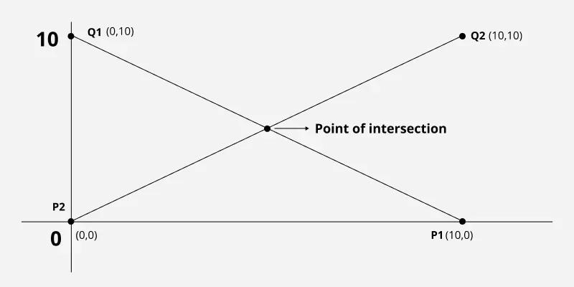
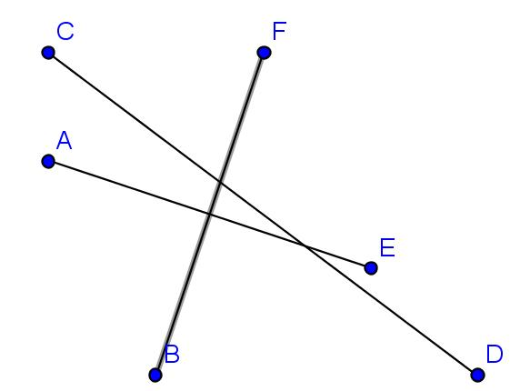
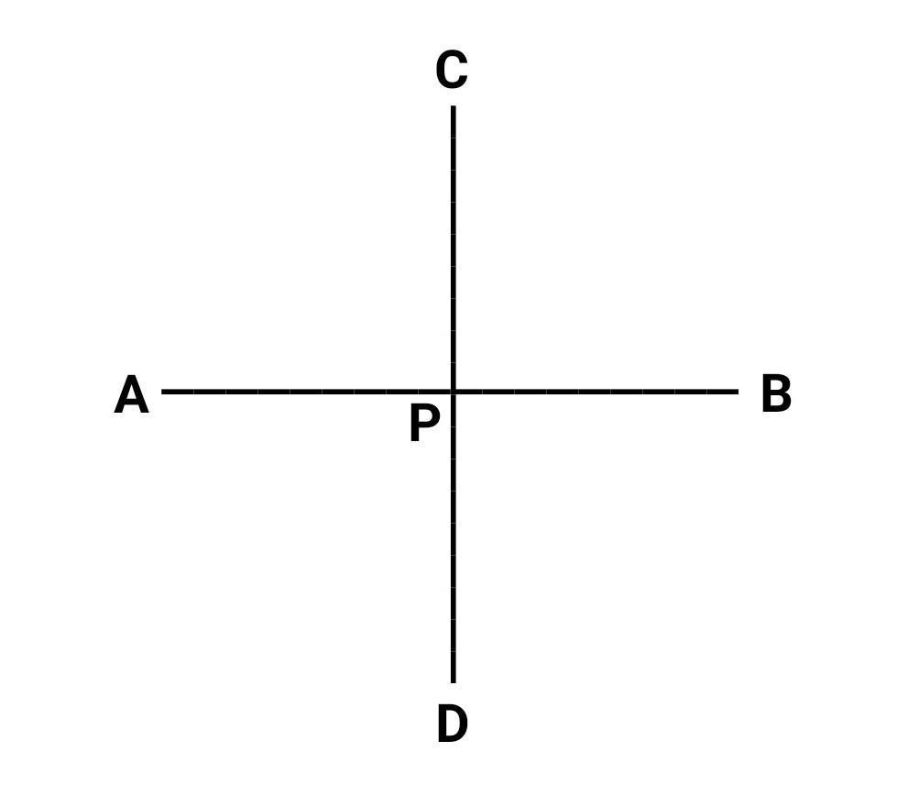

Purpose
# Source: AI Source: Provided by: [Data Path: Persons Table -> ID Column: 1, Name_En Column: Motasem Essam] -> From: [ChatGPT] on [7/25/2026]
Segment intersection is used to:
- Determine where line segments meet.
- Find crossing points within geometric figures.
- Analyze polygons and their diagonals.
- Determine whether two segments cross.
- Calculate intersection coordinates.
- Divide segments into smaller segments.
- Analyze geometric networks.
- Support CAD, engineering, surveying, GIS, and computer graphics.

Fundamental Idea
# Source: AI Source: Provided by: [Data Path: Persons Table -> ID Column: 1, Name_En Column: Motasem Essam] -> From: [ChatGPT] on [7/25/2026]
A line segment has two endpoints and contains all points between them.
A segment intersection occurs when two segments have at least one point in common.
For example:
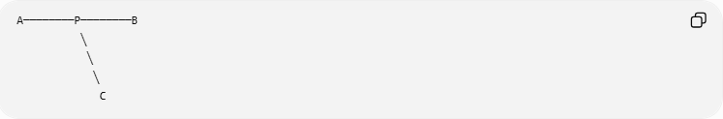
A────────P────────B
╲
╲
╲
C
Here, $P$ belongs to both segments.
Therefore:
$$\boxed{\overline{AB}∩\overline{CD}=\{P\}}$$
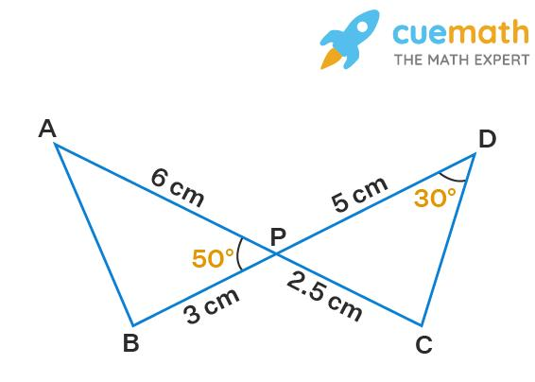
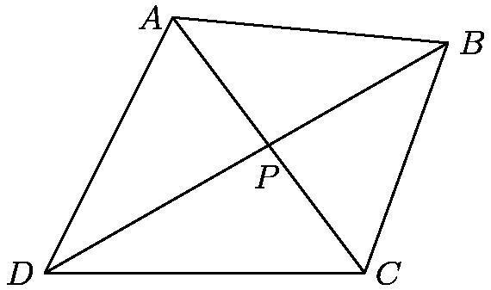
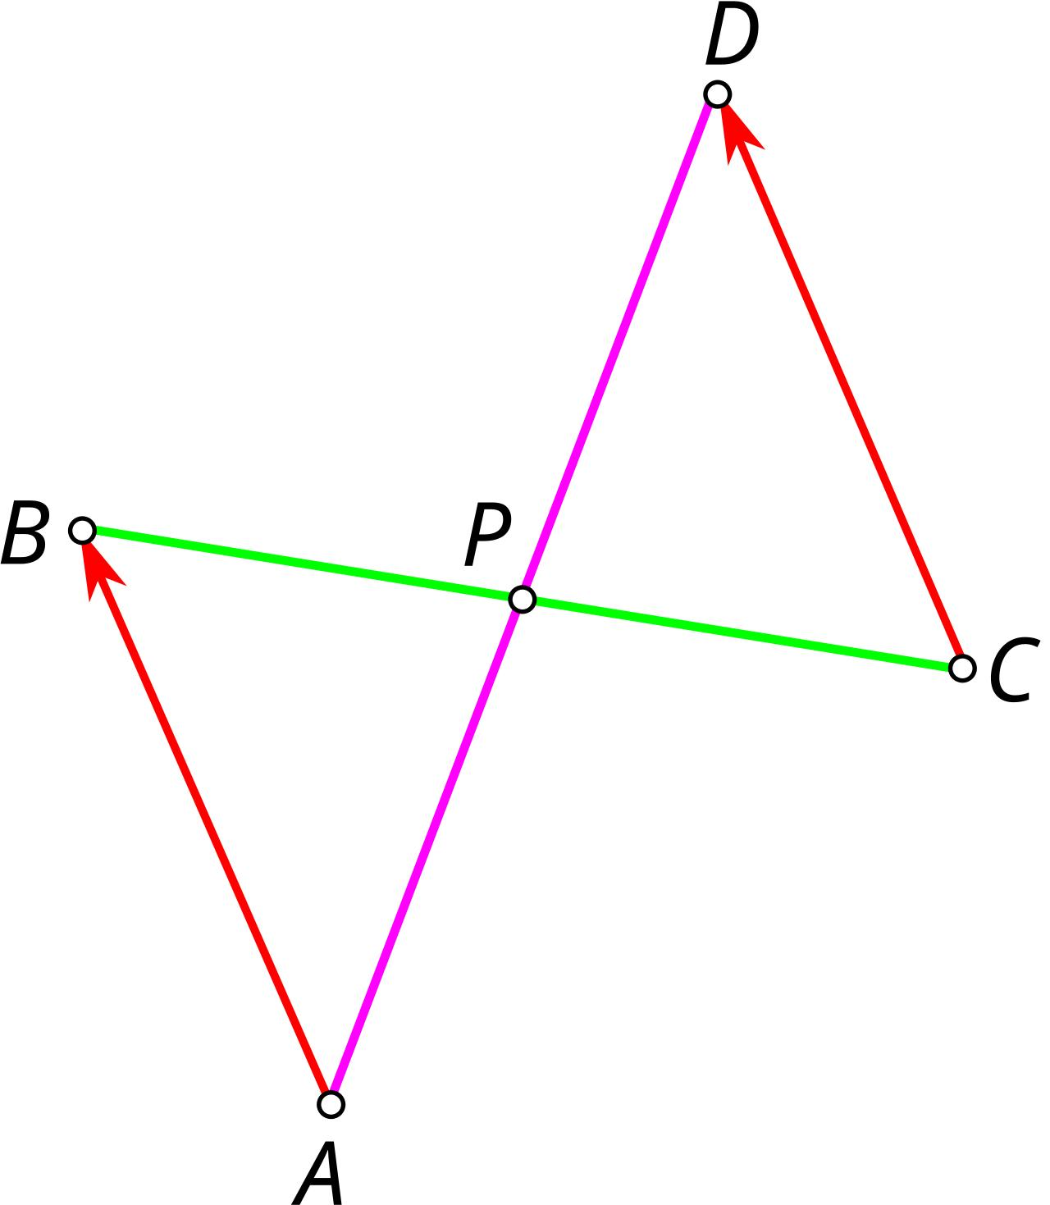

Mathematical Representation
# Source: AI Source: Provided by: [Data Path: Persons Table -> ID Column: 1, Name_En Column: Motasem Essam] -> From: [ChatGPT] on [7/25/2026]
If two segments share exactly one point:
$$\boxed{\overline{AB}∩\overline{CD}=\{P\}}$$
If two segments share several points because they overlap:
$$\boxed{\overline{AB}∩\overline{CD}=\overline{PQ}}$$
If they do not meet:
$$\boxed{\overline{AB}∩\overline{CD}=∅}$$

Types of Segment Intersection
# Source: AI Source: Provided by: [Data Path: Persons Table -> ID Column: 1, Name_En Column: Motasem Essam] -> From: [ChatGPT] on [7/25/2026]
Segment intersections can occur in several ways:
- Interior Intersection
- Endpoint Intersection
- Overlapping Segment Intersection
- No Intersection

1. Interior Intersection
# Source: AI Source: Provided by: [Data Path: Persons Table -> ID Column: 1, Name_En Column: Motasem Essam] -> From: [ChatGPT] on [7/25/2026]
An interior intersection occurs when two segments cross at a point that is inside both segments, rather than at an endpoint.
For example:
$$\boxed{\overline{AB}∩\overline{CD}=\{P\}}$$
where $P$ lies between $A$ and $B$, and also between $C$ and $D$.
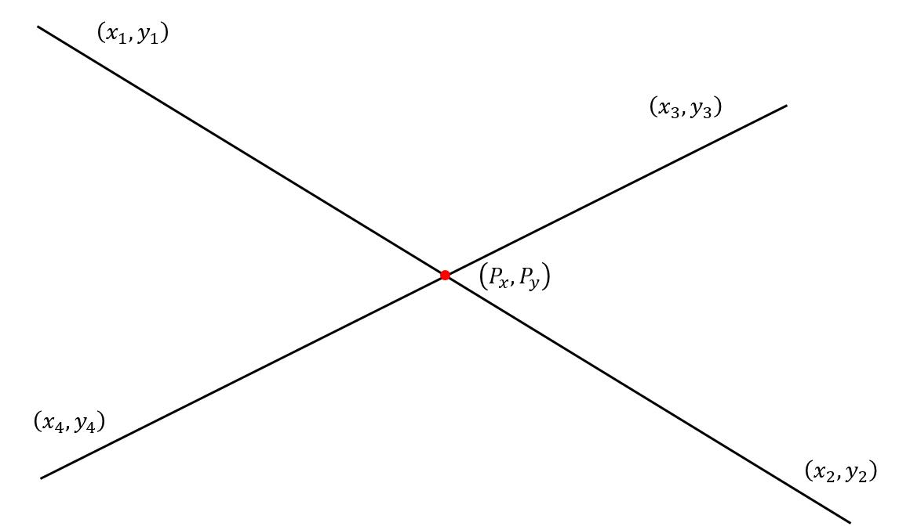
This is the most common type of segment crossing.

2. Endpoint Intersection
# Source: AI Source: Provided by: [Data Path: Persons Table -> ID Column: 1, Name_En Column: Motasem Essam] -> From: [ChatGPT] on [7/25/2026]
An endpoint intersection occurs when the endpoint of one segment lies on the other segment.
For example:
$$\boxed{\overline{AB}∩\overline{BC}=\{B\}}$$
The segments share the endpoint (B).
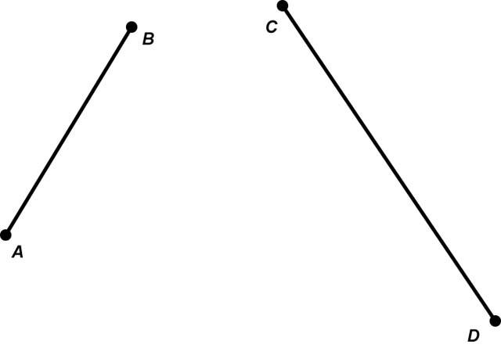
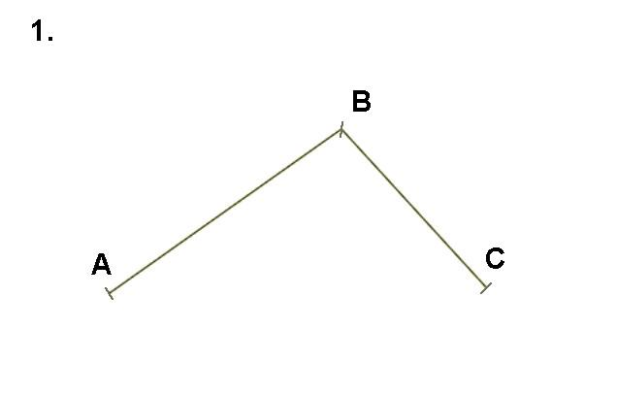
This occurs frequently in polygons.
For example, adjacent sides of a triangle share a vertex.

3. Overlapping Segment Intersection
# Source: AI Source: Provided by: [Data Path: Persons Table -> ID Column: 1, Name_En Column: Motasem Essam] -> From: [ChatGPT] on [7/25/2026]
Two collinear segments can overlap over a portion of their lengths.
For example:
A────────────B
C────────────D
The common portion is:
$$\boxed{\overline{CB}}$$
Therefore:
$$\boxed{\overline{AB}∩\overline{CD}=\overline{CB}}$$
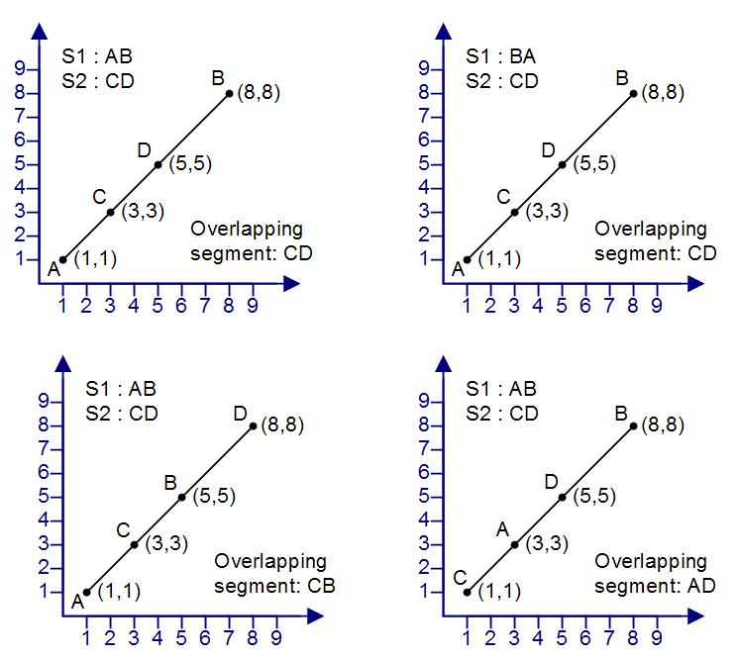
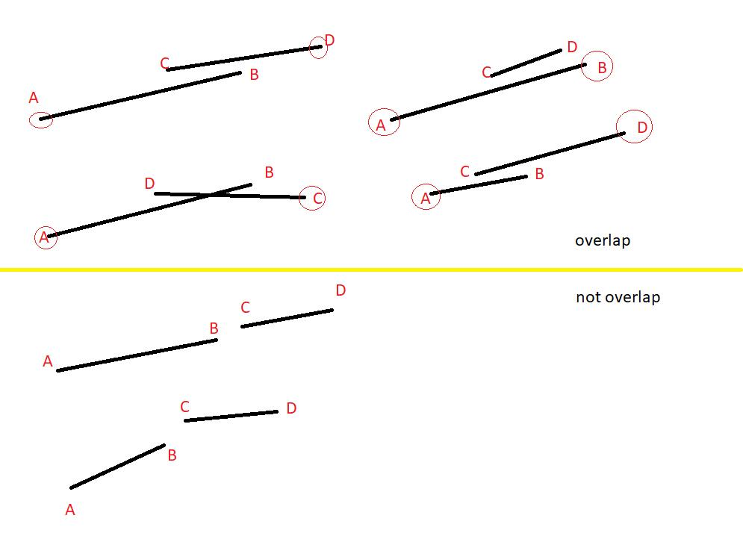
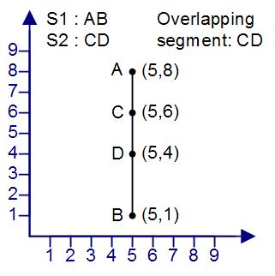
This is different from a point intersection because the intersection contains infinitely many points.

4. No Segment Intersection
# Source: AI Source: Provided by: [Data Path: Persons Table -> ID Column: 1, Name_En Column: Motasem Essam] -> From: [ChatGPT] on [7/25/2026]
Two line segments may have no common points.
For example:
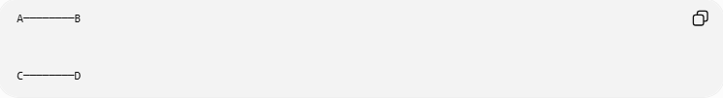
A────────B

C────────D
If the segments do not touch:
$$\boxed{\overline{AB}∩\overline{CD}=∅}$$
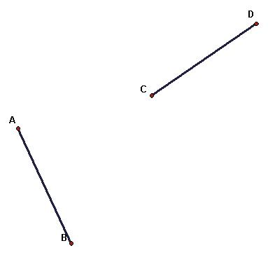
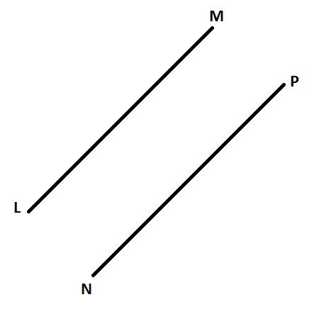
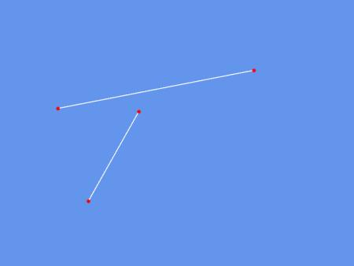

Segment Intersection vs. Line Intersection
# Source: AI Source: Provided by: [Data Path: Persons Table -> ID Column: 1, Name_En Column: Motasem Essam] -> From: [ChatGPT] on [7/25/2026]
A major difference exists between a line and a line segment.
A line extends infinitely in both directions:
$$\overset{↔}{AB}$$
A segment has two endpoints:
$$\overline{AB}$$
Two lines may intersect outside the portions represented by two segments.
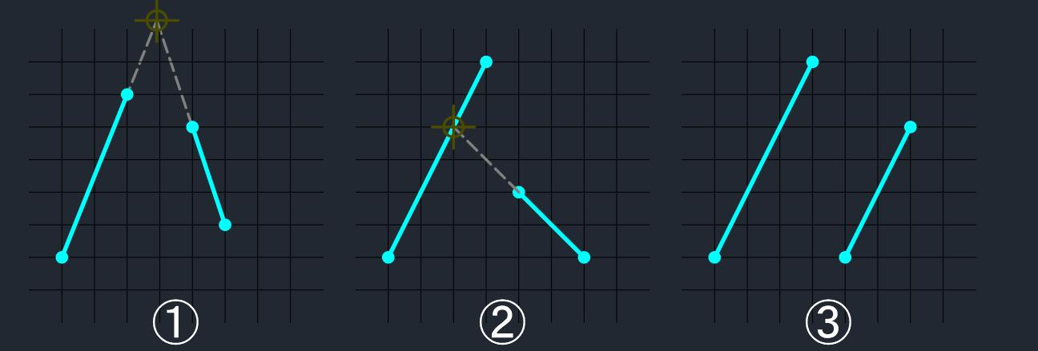
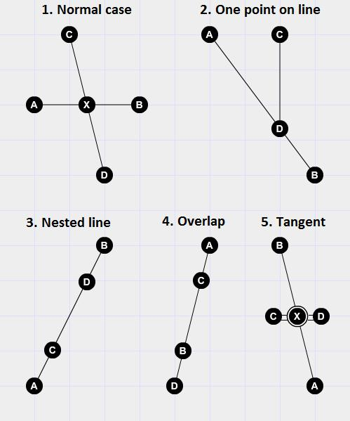
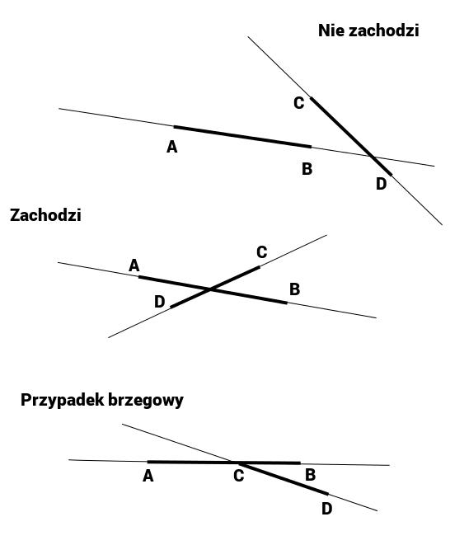
Therefore, two segments intersect only if their finite portions actually share a point.

Segment Intersection in a Triangle
# Source: AI Source: Provided by: [Data Path: Persons Table -> ID Column: 1, Name_En Column: Motasem Essam] -> From: [ChatGPT] on [7/25/2026]
The sides of a triangle intersect at their endpoints.
For triangle $ABC$:
$$\boxed{\overline{AB}∩\overline{BC}=\{B\}}$$
and:
$$\boxed{\overline{BC}∩\overline{CA}=\{C\}}$$
and:
$$\boxed{\overline{CA}∩\overline{AB}=\{A\}}$$
These intersections form the vertices of the triangle.

Segment Intersection in a Quadrilateral
# Source: AI Source: Provided by: [Data Path: Persons Table -> ID Column: 1, Name_En Column: Motasem Essam] -> From: [ChatGPT] on [7/25/2026]
Adjacent sides of a quadrilateral intersect at their endpoints.
For example:
$$\boxed{\overline{AB}∩\overline{BC}=\{B\}}$$
However, the diagonals can intersect at an interior point.
For a quadrilateral $ABCD$:
$$\boxed{\overline{AC}∩\overline{BD}=\{P\}}$$
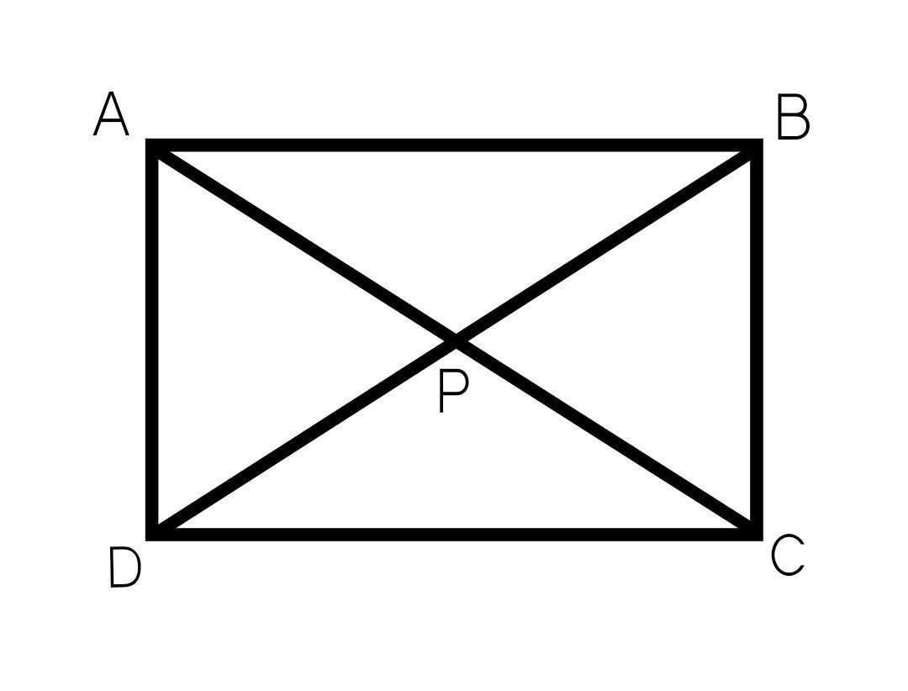
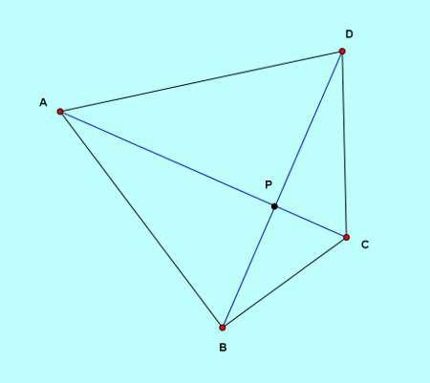
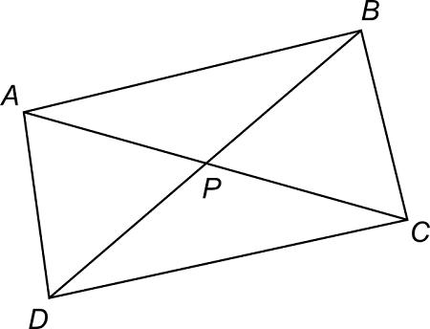

Segment Intersection of Polygon Diagonals
# Source: AI Source: Provided by: [Data Path: Persons Table -> ID Column: 1, Name_En Column: Motasem Essam] -> From: [ChatGPT] on [7/25/2026]
Diagonals of a polygon can intersect inside the polygon.
For example, in a pentagon, several diagonals may cross at different points.
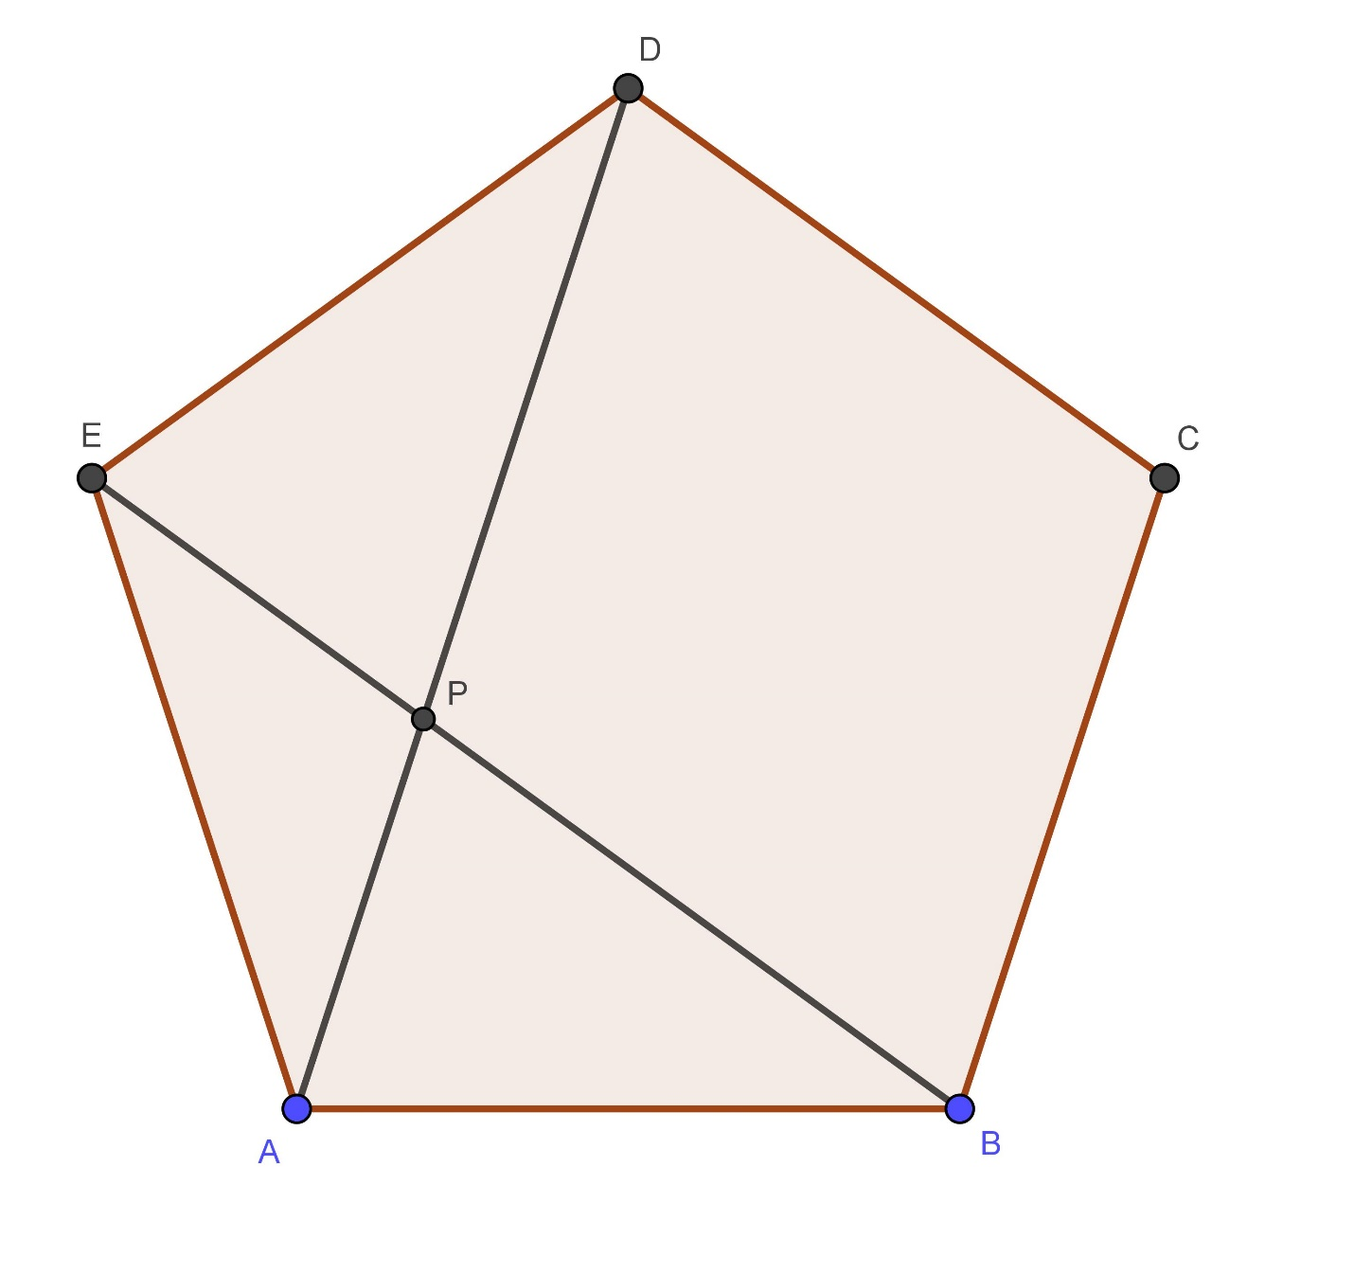
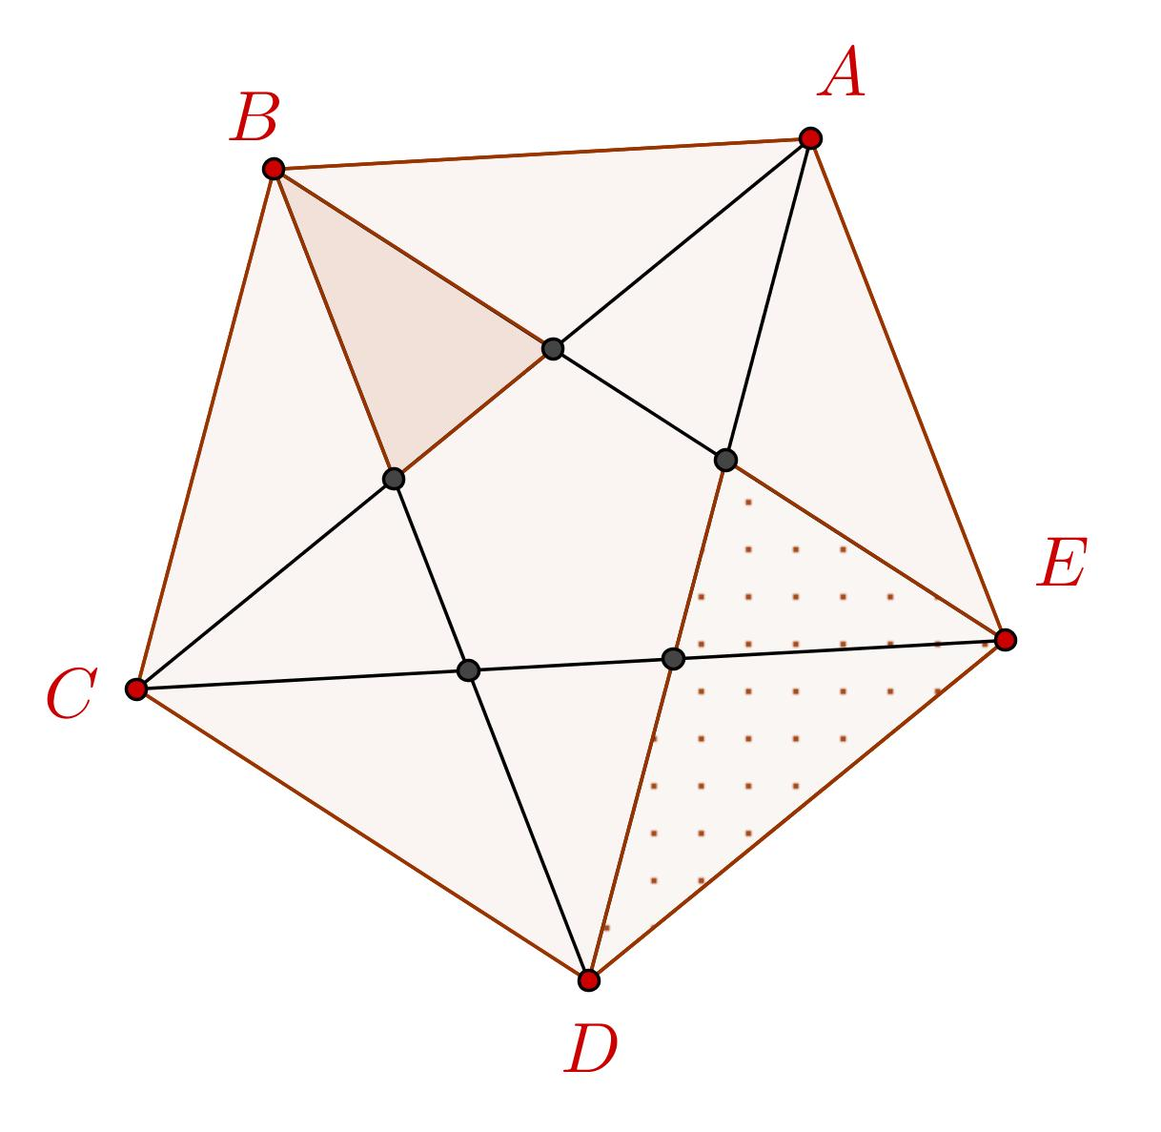
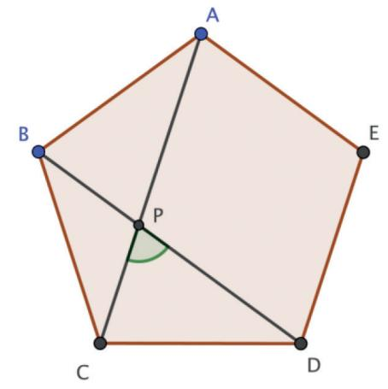
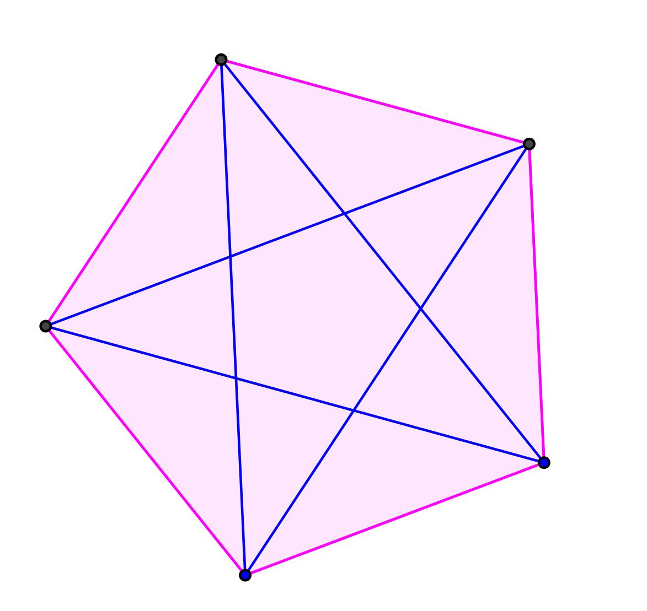
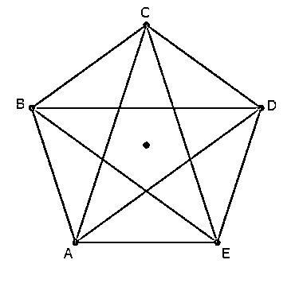
These intersection points can divide the polygon into smaller regions.

Segment Intersection and Convex Polygons
# Source: AI Source: Provided by: [Data Path: Persons Table -> ID Column: 1, Name_En Column: Motasem Essam] -> From: [ChatGPT] on [7/25/2026]
In a convex polygon, the intersection of two diagonals, when they cross, lies inside the polygon.
For example:
$$\boxed{\overline{AC}∩\overline{BD}=\{P\}}$$
where $P$ is inside the polygon.
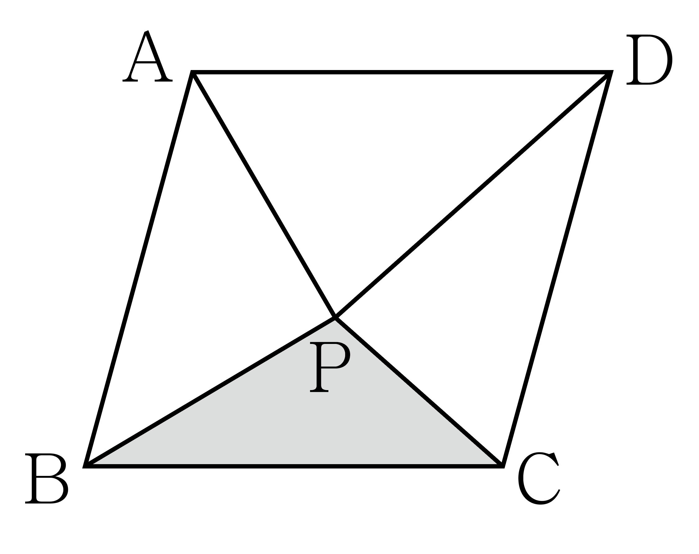

Segment Intersection and Concave Polygons
# Source: AI Source: Provided by: [Data Path: Persons Table -> ID Column: 1, Name_En Column: Motasem Essam] -> From: [ChatGPT] on [7/25/2026]
In a concave polygon, some segments connecting vertices may extend outside the polygon.
Therefore, geometric segment relationships can be more complicated.
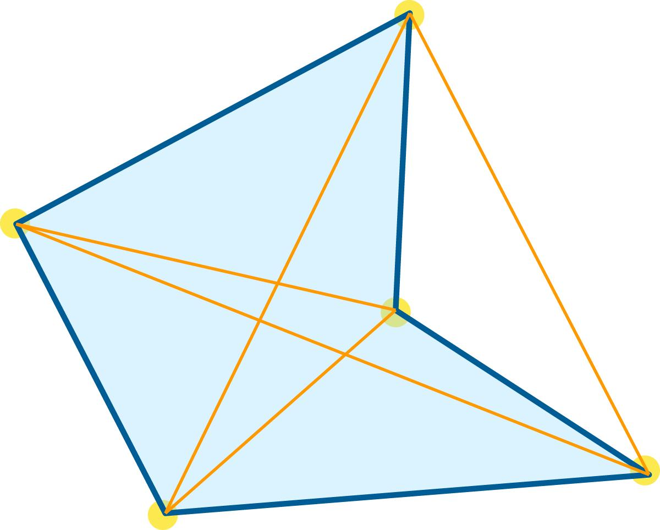
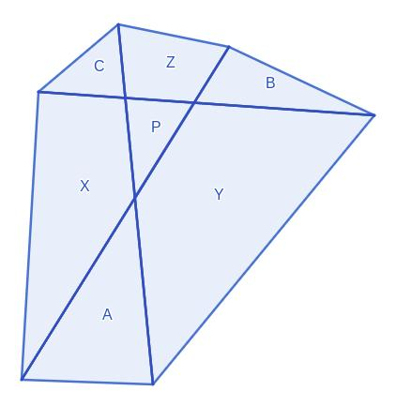
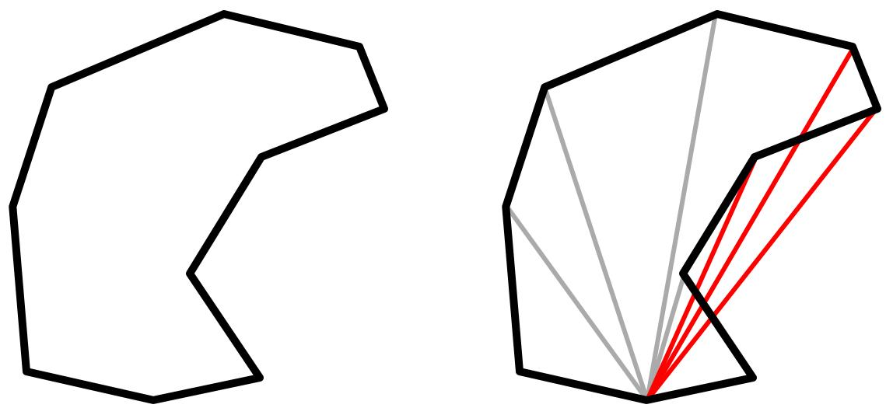
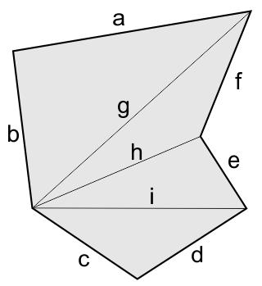
The segment intersection itself is still determined by the actual finite segments.

Segment Intersection and Angles
# Source: AI Source: Provided by: [Data Path: Persons Table -> ID Column: 1, Name_En Column: Motasem Essam] -> From: [ChatGPT] on [7/25/2026]
When two segments cross at an interior point, they form angles around their intersection.
For example:
$$\boxed{\overline{AB}∩\overline{CD}=\{P\}}$$
The crossing creates four angles around $P$.
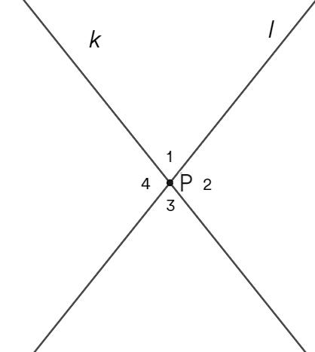
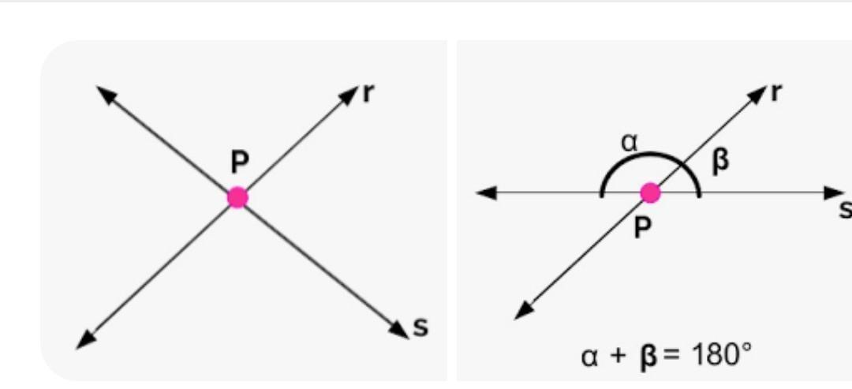
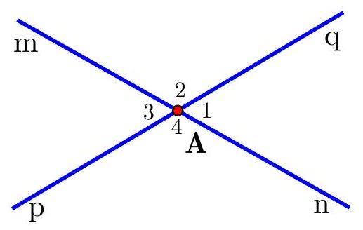
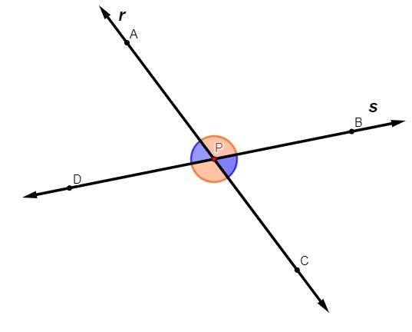
If the segments are perpendicular:
$$\boxed{\overline{AB}⊥\overline{CD}}$$
then all four angles are:
$$\boxed{{90}^{∘}}$$

Segment Intersection and Perpendicularity
# Source: AI Source: Provided by: [Data Path: Persons Table -> ID Column: 1, Name_En Column: Motasem Essam] -> From: [ChatGPT] on [7/25/2026]
Perpendicularity can occur between two line segments.
If:
$$\boxed{\overline{AB}∩\overline{CD}=\{P\}}$$
and they meet at ${90}^{∘}$, then:
$$\boxed{\overline{AB}⊥\overline{CD}}$$
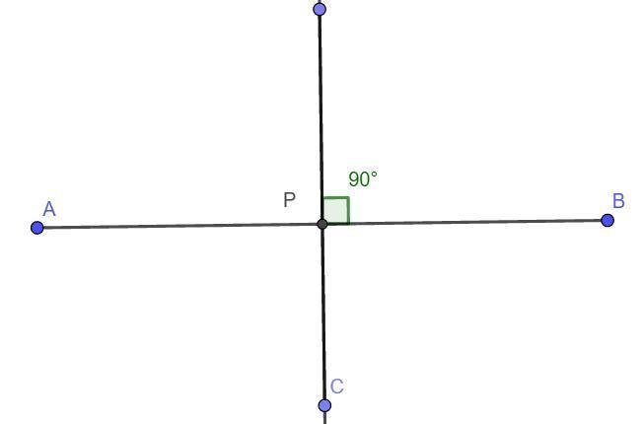
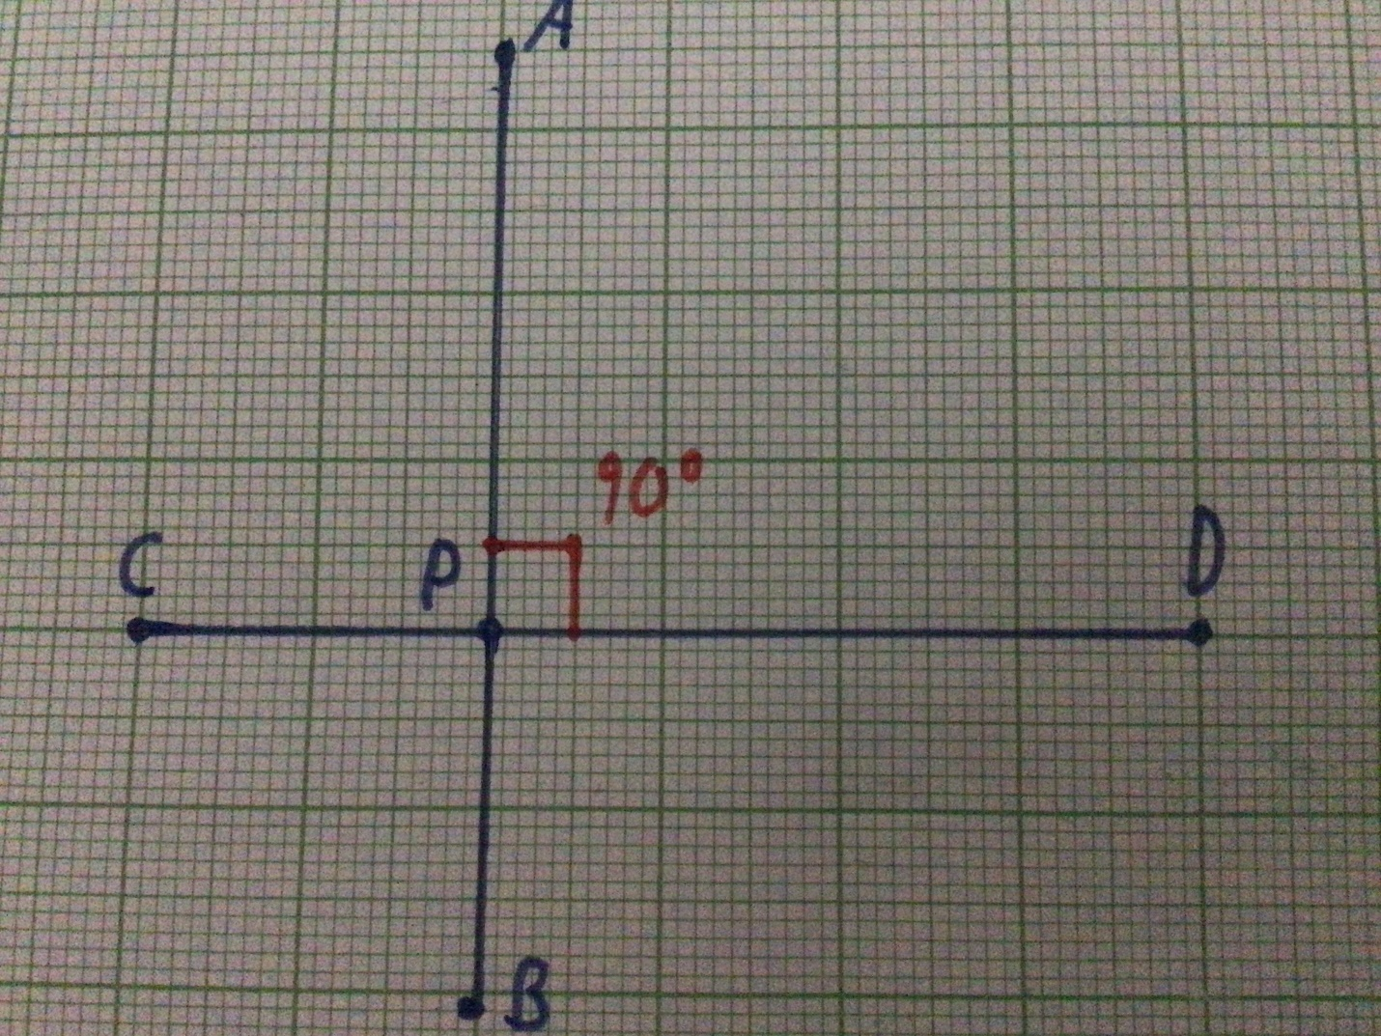
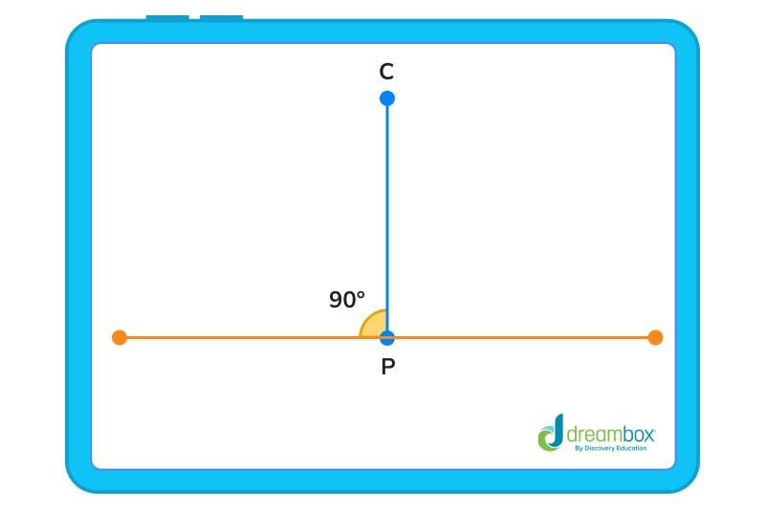
Thus, perpendicularity is a special case of segment intersection.

Segment Intersection in Coordinate Geometry
# Source: AI Source: Provided by: [Data Path: Persons Table -> ID Column: 1, Name_En Column: Motasem Essam] -> From: [ChatGPT] on [7/25/2026]
A segment can be represented by its endpoints.
For example:
$$A=\left(x_{1},y_{1}\right)$$
and:
$$B=\left(x_{2},y_{2}\right)$$
define the segment:
$$\boxed{\overline{AB}}$$
Another segment can be defined by:
$$C=\left(x_{3},y_{3}\right)$$
and:
$$D=\left(x_{4},y_{4}\right)$$
The problem of segment intersection is to determine whether:
$$\boxed{\overline{AB}∩\overline{CD}≠∅}$$
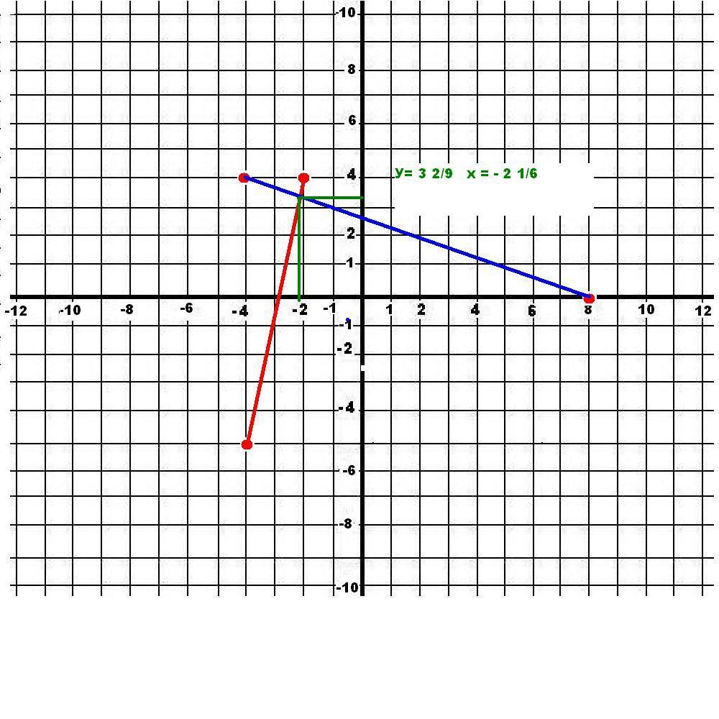
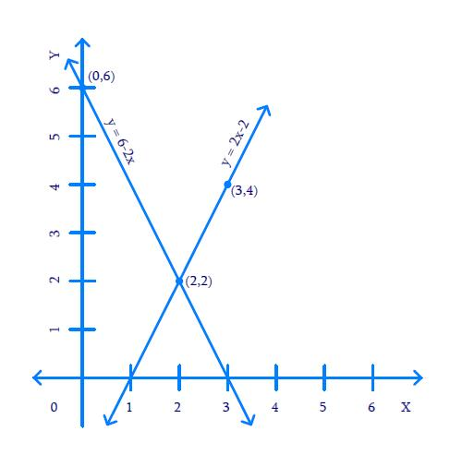
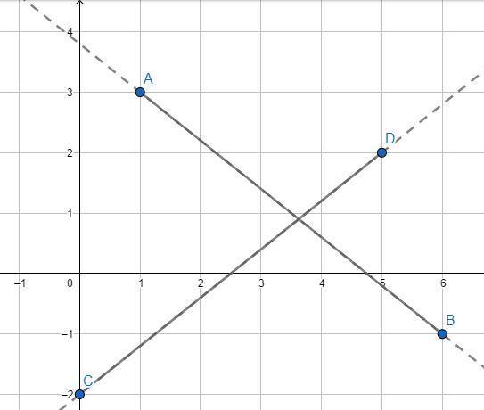
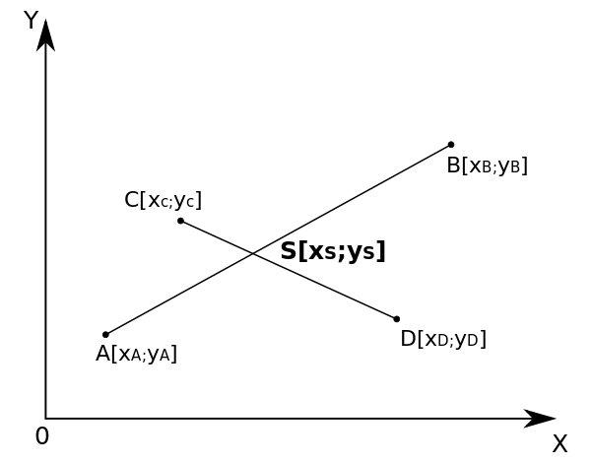

Example of Coordinate Segment Intersection
# Source: AI Source: Provided by: [Data Path: Persons Table -> ID Column: 1, Name_En Column: Motasem Essam] -> From: [ChatGPT] on [7/25/2026]
Consider:
$$A=\left(0,0\right) \\ B=\left(4,4\right)$$
and:
$$C=\left(0,4\right) \\ D=\left(4,0\right)$$
The segments cross at:
$$\boxed{P=\left(2,2\right)}$$
Therefore:
$$\boxed{\overline{AB}∩\overline{CD}=\{\left(2,2\right)\}}$$
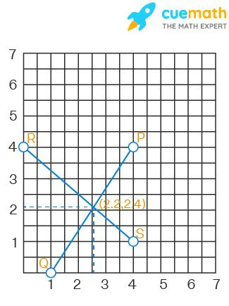
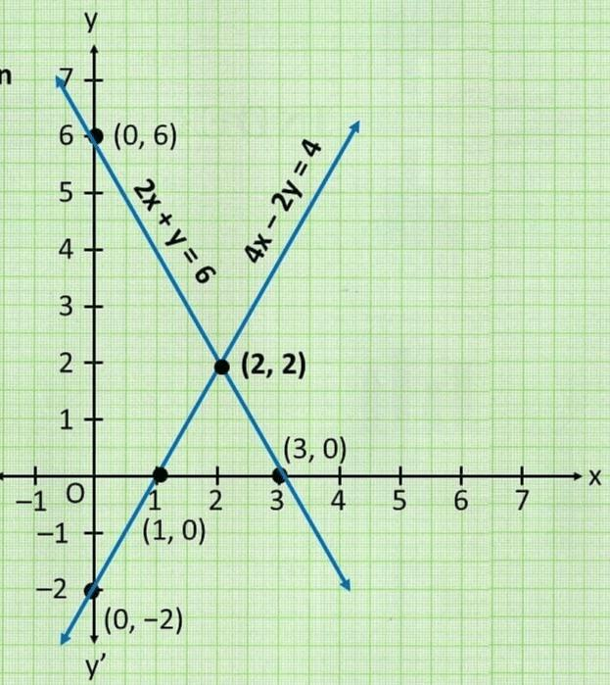
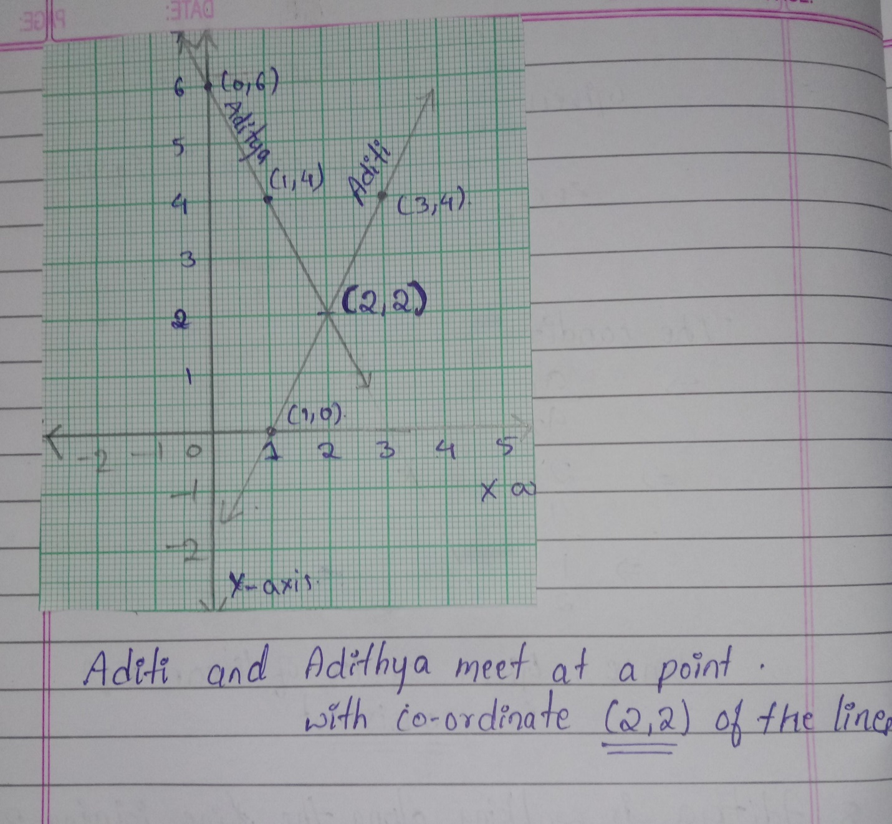

Segment Intersection and Orientation
# Source: AI Source: Provided by: [Data Path: Persons Table -> ID Column: 1, Name_En Column: Motasem Essam] -> From: [ChatGPT] on [7/25/2026]
In computational geometry, the intersection of two segments can be determined using the orientation of points.
For three points $A,B,C$, their orientation can be:
- Clockwise.
- Counterclockwise.
- Collinear.
This allows algorithms to determine whether two segments cross.

Collinear Segment Intersection
# Source: AI Source: Provided by: [Data Path: Persons Table -> ID Column: 1, Name_En Column: Motasem Essam] -> From: [ChatGPT] on [7/25/2026]
If two segments lie on the same line, they are collinear.
They can:
- Not overlap.
- Touch at one endpoint.
- Overlap over a segment.
For example:
$$\overline{AB}∥\overline{CD}$$
in the sense that they lie on the same supporting line, and their actual positions determine the intersection.
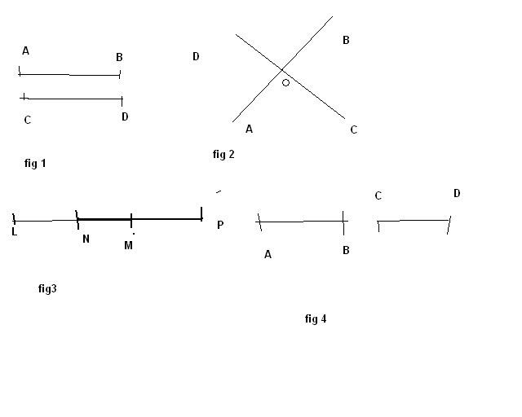

Segment Intersection in CAD
# Source: AI Source: Provided by: [Data Path: Persons Table -> ID Column: 1, Name_En Column: Motasem Essam] -> From: [ChatGPT] on [7/25/2026]
CAD systems frequently calculate intersections between line segments and other objects.
Examples include:
- Line segment–line segment.
- Segment–arc.
- Segment–circle.
- Segment–polygon.
- Segment–curve.
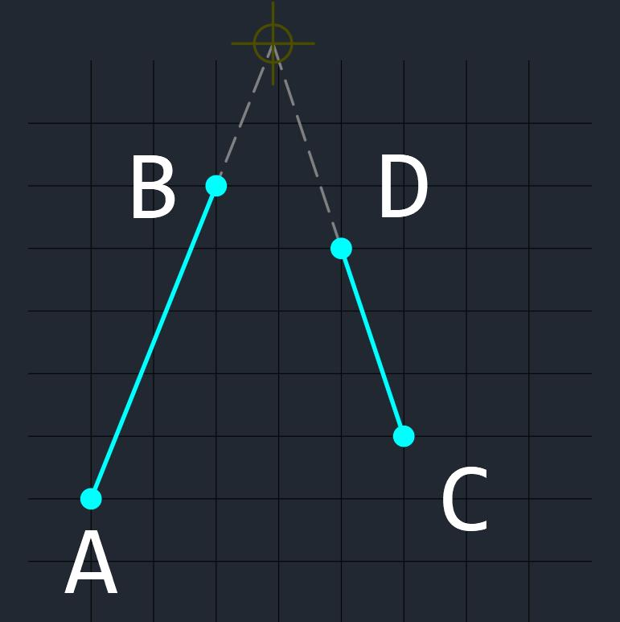
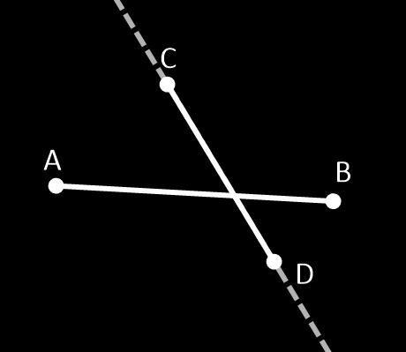
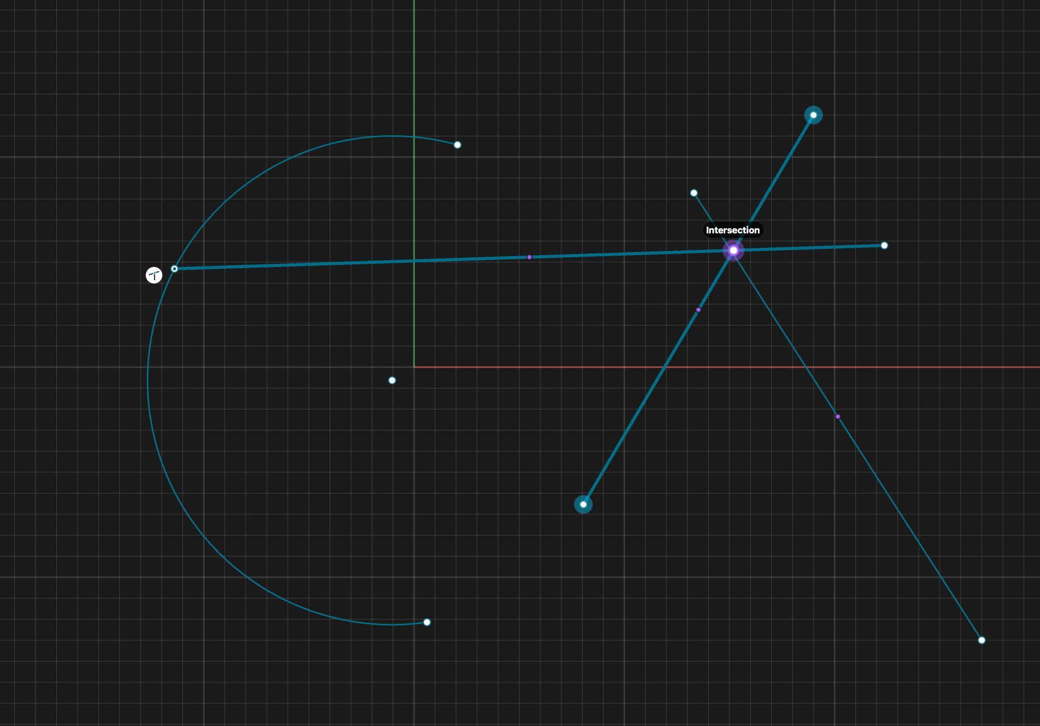
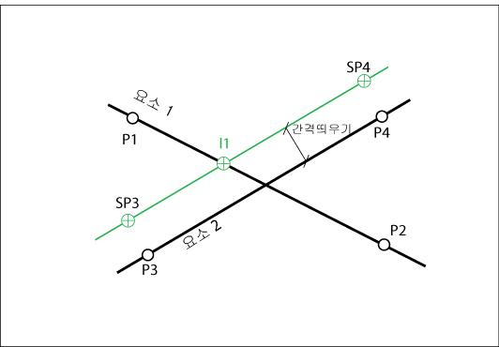
Intersection points can be used to:
- Trim lines.
- Split segments.
- Create vertices.
- Build boundaries.
- Construct complex drawings.

Segment Intersection in Architecture
# Source: AI Source: Provided by: [Data Path: Persons Table -> ID Column: 1, Name_En Column: Motasem Essam] -> From: [ChatGPT] on [7/25/2026]
Architectural drawings contain many intersecting segments.
Examples include:
- Walls.
- Structural lines.
- Floor-plan boundaries.
- Roof edges.
- Doors and windows.
- Grid systems.
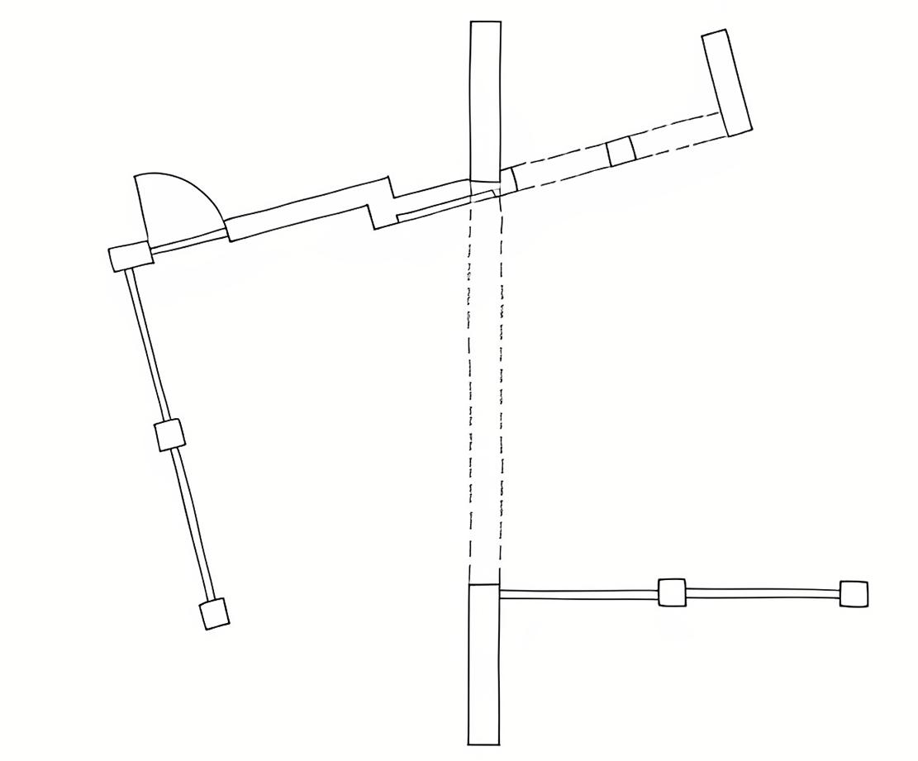
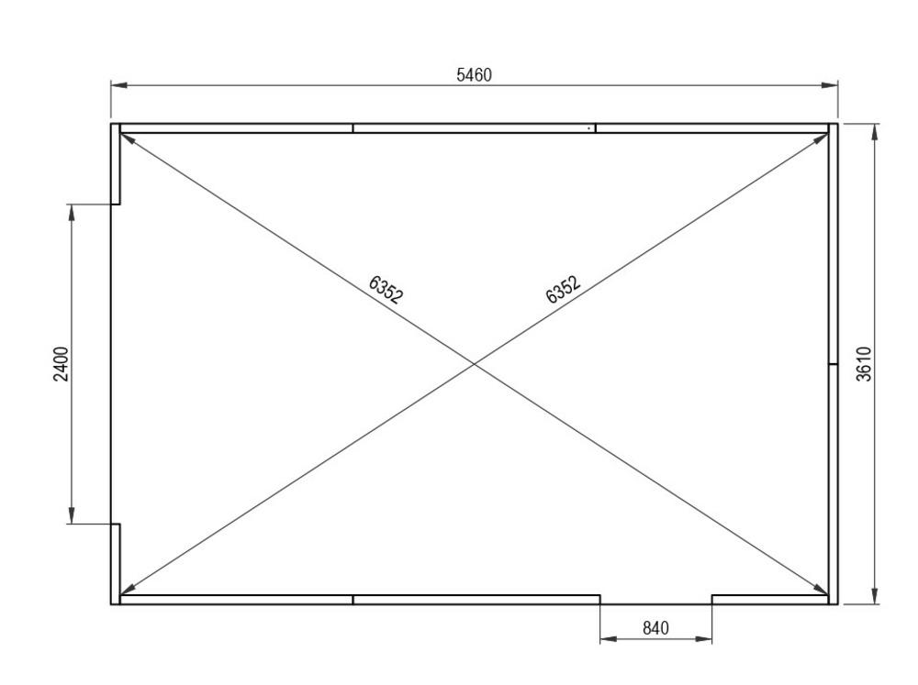
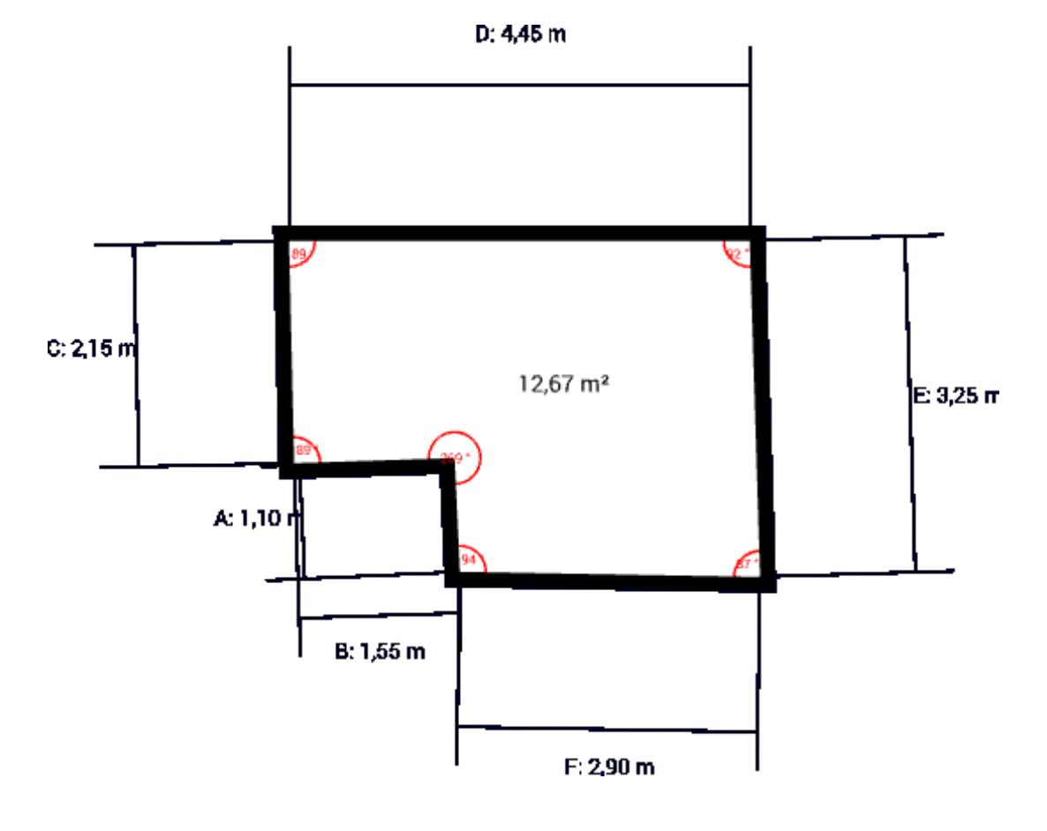

Segment Intersection in Engineering
# Source: AI Source: Provided by: [Data Path: Persons Table -> ID Column: 1, Name_En Column: Motasem Essam] -> From: [ChatGPT] on [7/25/2026]
Engineering designs use segment intersections to represent:
- Structural connections.
- Machine components.
- Frameworks.
- Pipes.
- Mechanical joints.
- Technical drawings.
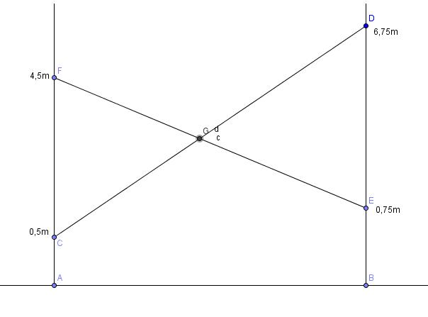
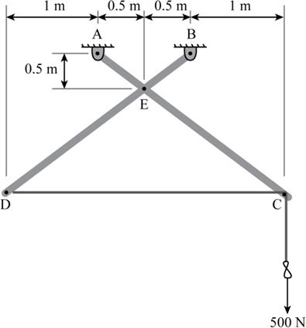
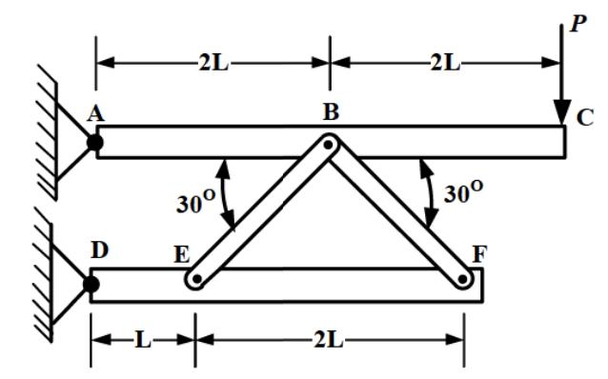
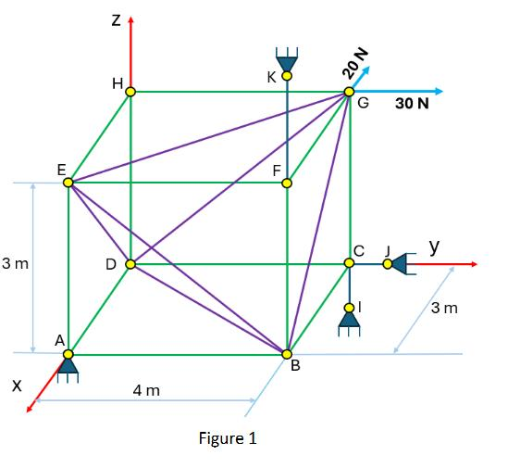

Segment Intersection in GIS and Mapping
# Source: AI Source: Provided by: [Data Path: Persons Table -> ID Column: 1, Name_En Column: Motasem Essam] -> From: [ChatGPT] on [7/25/2026]
Maps represent many real-world objects using line segments.
Examples include:
- Roads.
- Borders.
- Rivers.
- Railway lines.
- Utility networks.
Intersection calculations can identify where these features cross.
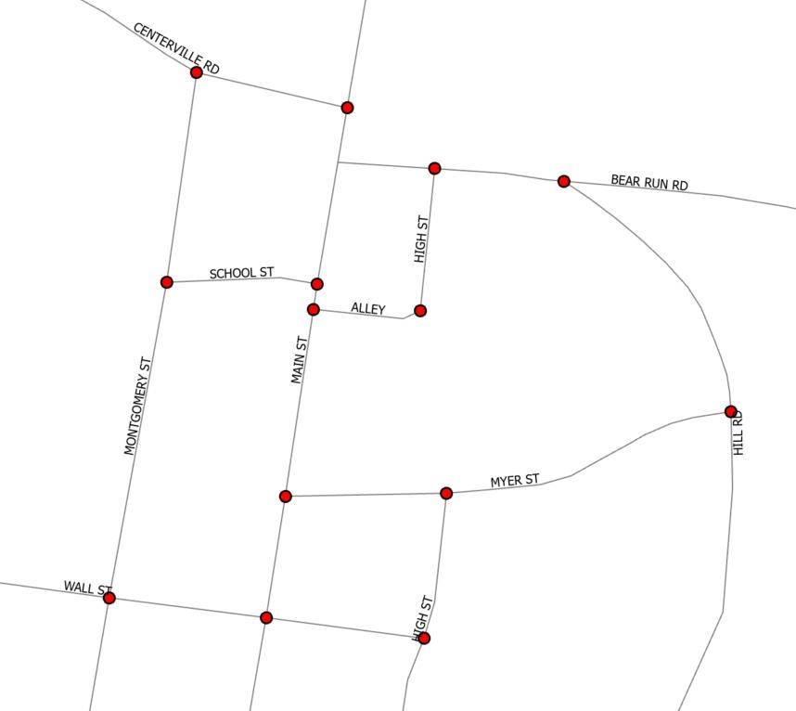
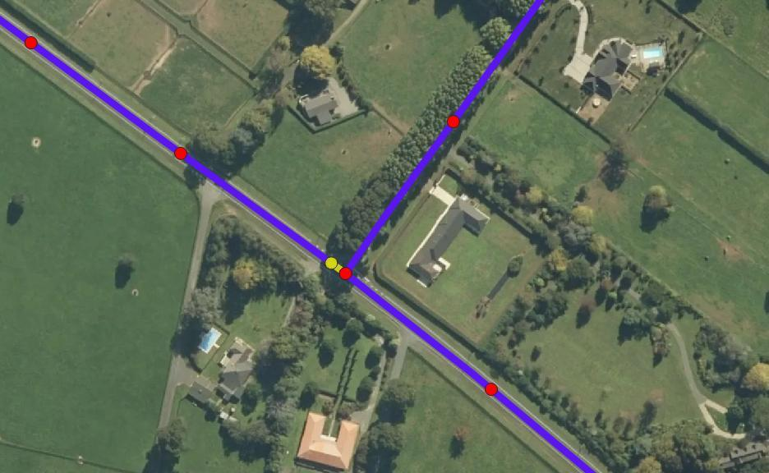
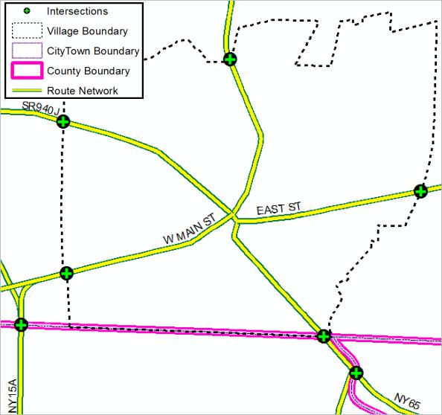
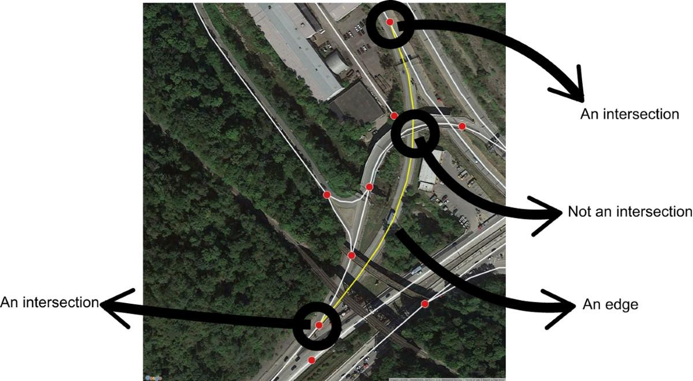
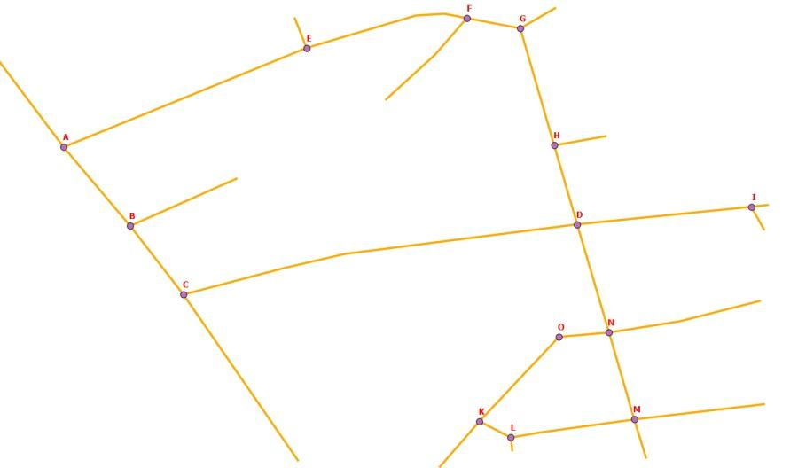

Segment Intersection in Computer Graphics
# Source: AI Source: Provided by: [Data Path: Persons Table -> ID Column: 1, Name_En Column: Motasem Essam] -> From: [ChatGPT] on [7/25/2026]
Computer graphics uses segment intersection for:
- Collision detection.
- Polygon clipping.
- Shape construction.
- 2D games.
- Vector graphics.
- Geometric modeling.
For example, a moving line segment can be tested against another segment to determine whether they collide.
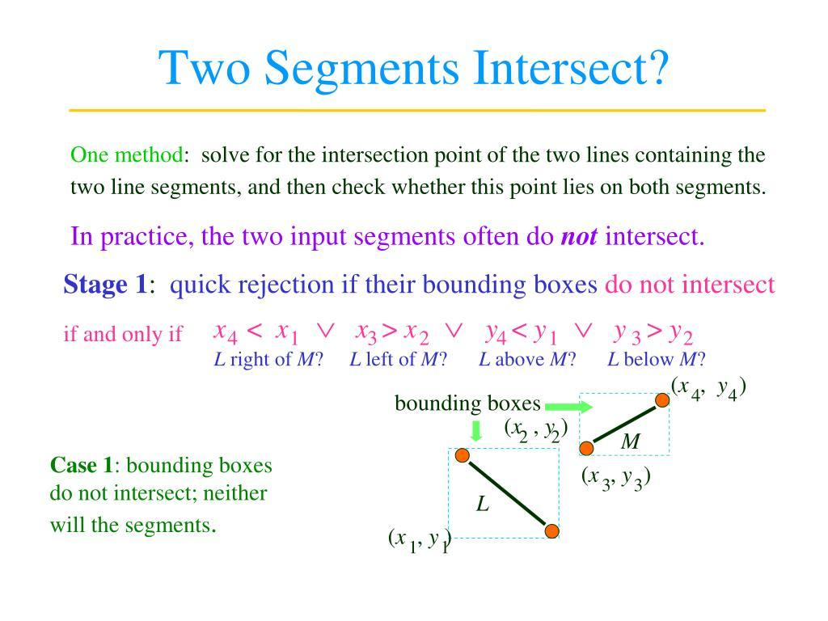
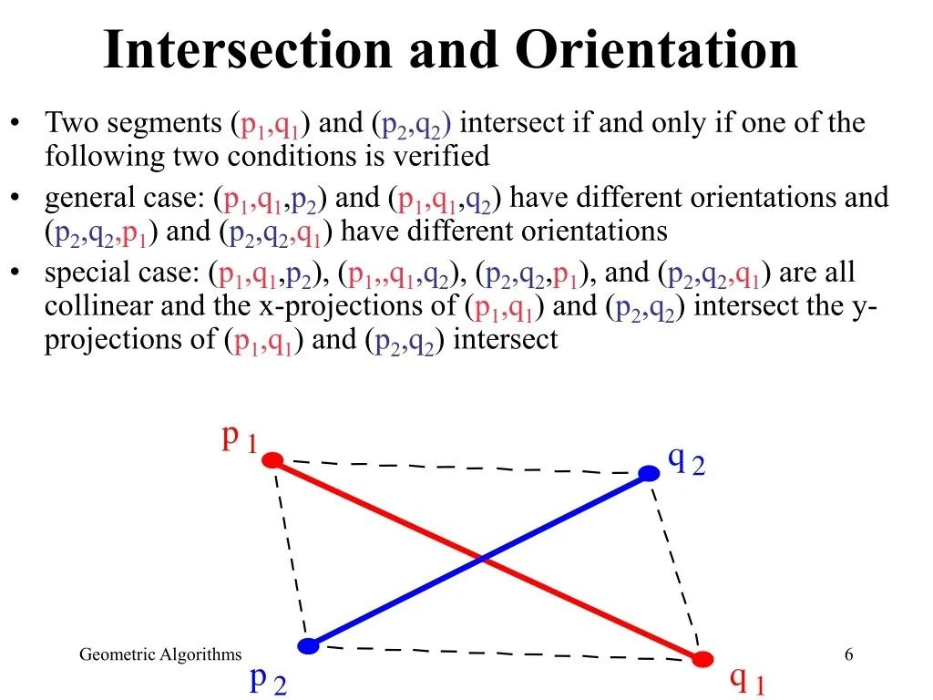
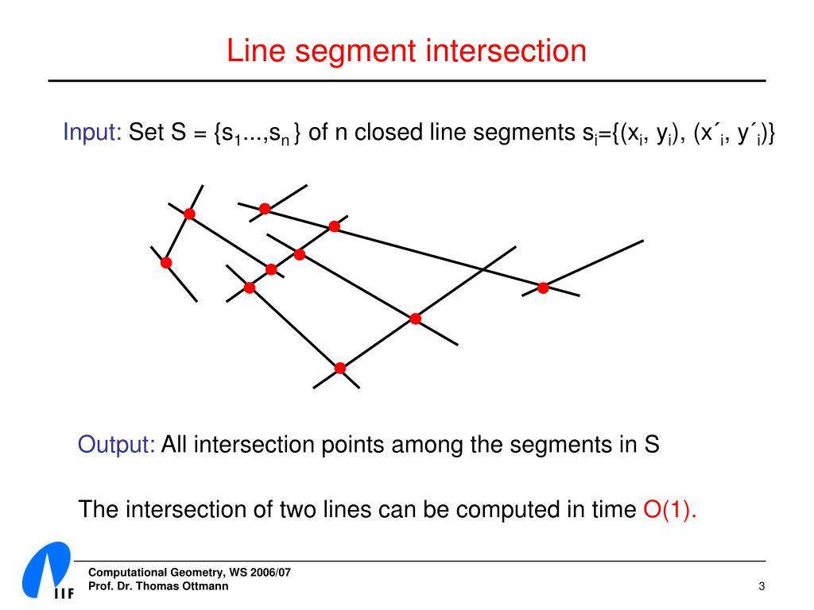
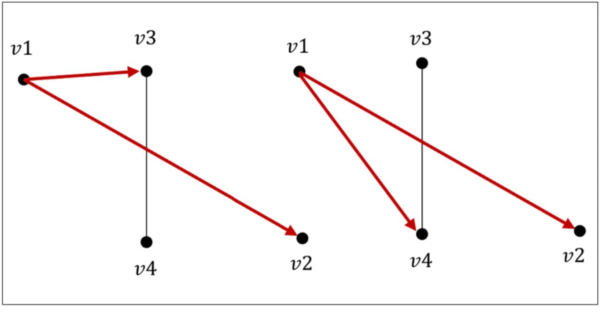

Real-World Examples
# Source: AI Source: Provided by: [Data Path: Persons Table -> ID Column: 1, Name_En Column: Motasem Essam] -> From: [ChatGPT] on [7/25/2026]
Segment intersections can represent:
- Two roads crossing.
- Two sticks crossing.
- Two walls meeting.
- Two beams crossing.
- Two paths crossing.
- Lines drawn on a map.
- Edges of polygons meeting.
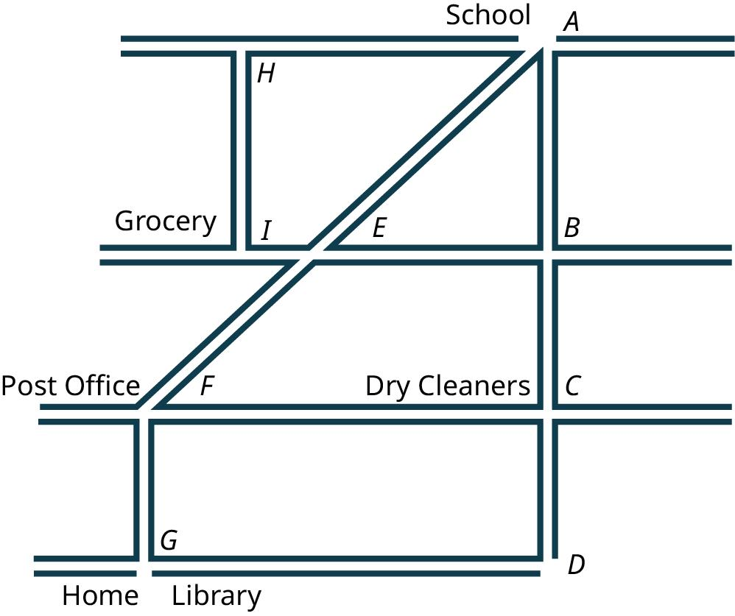
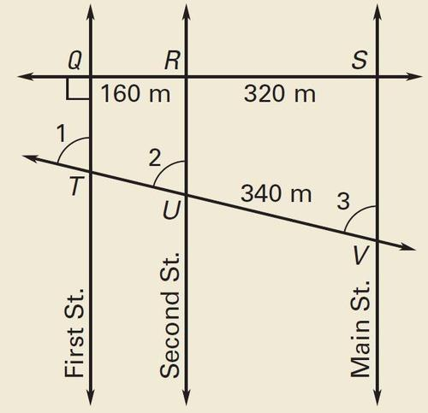
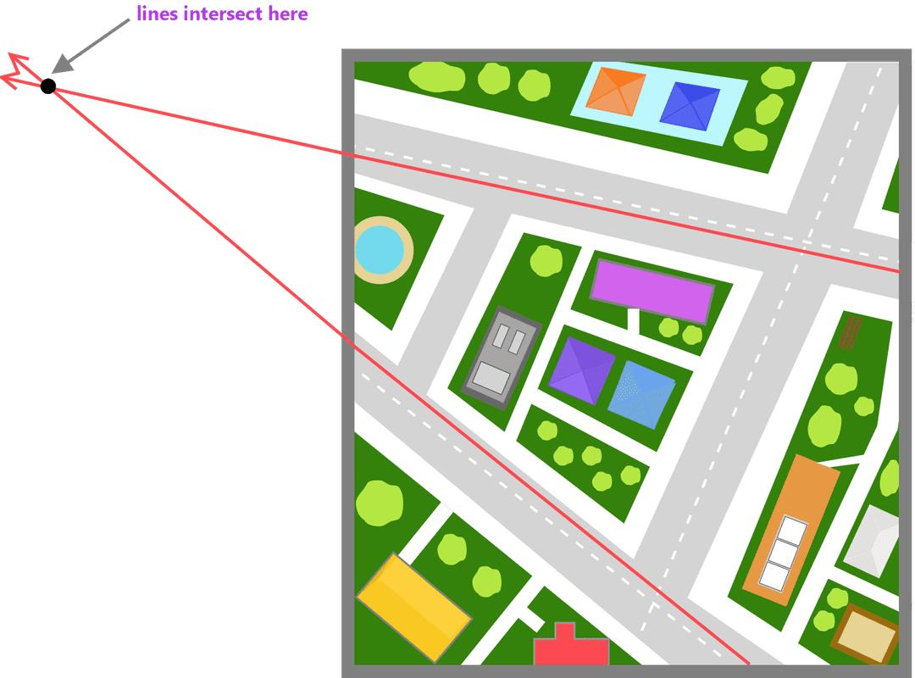

Applications
# Source: AI Source: Provided by: [Data Path: Persons Table -> ID Column: 1, Name_En Column: Motasem Essam] -> From: [ChatGPT] on [7/25/2026]
Segment intersection is important in:
- Plane Geometry
- Coordinate Geometry
- Euclidean Geometry
- Computational Geometry
- Polygon Theory
- Architecture
- Civil Engineering
- Mechanical Engineering
- Surveying
- GIS
- CAD
- Computer Graphics
- Robotics
- Navigation

Advantages
# Source: AI Source: Provided by: [Data Path: Persons Table -> ID Column: 1, Name_En Column: Motasem Essam] -> From: [ChatGPT] on [7/25/2026]
Studying segment intersection helps to:
- Determine whether two segments cross.
- Find exact crossing points.
- Analyze polygon structures.
- Divide shapes into smaller regions.
- Detect collisions.
- Construct geometric figures.
- Analyze engineering structures.
- Calculate map and road intersections.
- Build accurate CAD models.

Limitations
# Source: AI Source: Provided by: [Data Path: Persons Table -> ID Column: 1, Name_En Column: Motasem Essam] -> From: [ChatGPT] on [7/25/2026]
Segment intersection:
- Applies specifically to finite line segments.
- Is different from intersection of infinite lines.
- Can involve endpoint contact or overlapping segments.
- Requires checking the actual positions of the endpoints.
- Can become computationally complex when many segments are involved.
- Visual inspection may not always be sufficient for very small or nearly touching intersections.

Comparison with Related Concepts
# Source: AI Source: Provided by: [Data Path: Persons Table -> ID Column: 1, Name_En Column: Motasem Essam] -> From: [ChatGPT] on [7/25/2026]
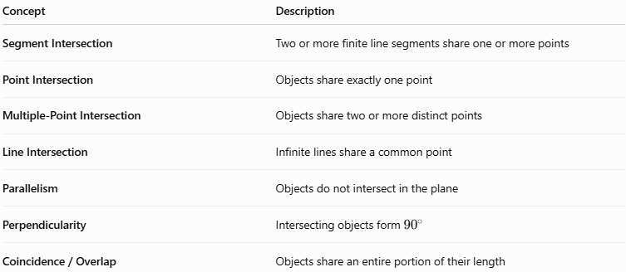
Concept | Description
Segment Intersection | Two or more finite line segments share one or more points
Point Intersection | Objects share exactly one point
Multiple-Point Intersection | Objects share two or more distinct points
Line Intersection | Infinite lines share a common point
Parallelism | Objects do not intersect in the plane
Perpendicularity | Intersecting objects form ${90}^{∘}$
Coincidence / Overlap | Objects share an entire portion of their length

Segment Intersection vs. Point Intersection
# Source: AI Source: Provided by: [Data Path: Persons Table -> ID Column: 1, Name_En Column: Motasem Essam] -> From: [ChatGPT] on [7/25/2026]
These concepts are related but not identical.
Segment Intersection describes the objects involved:
$$\boxed{\overline{AB}∩\overline{CD}}$$
Point Intersection describes the number of common points when there is exactly one:
$$\boxed{\overline{AB}∩\overline{CD}=\{P\}}$$
Therefore, a segment intersection can be a point intersection, an endpoint intersection, or an overlapping segment intersection.

Key Points
# Source: AI Source: Provided by: [Data Path: Persons Table -> ID Column: 1, Name_En Column: Motasem Essam] -> From: [ChatGPT] on [7/25/2026]
- A Segment Intersection occurs when two or more finite line segments share one or more points.
- Two segments can:
  - Cross at an interior point.
  - Meet at an endpoint.
  - Overlap along part of their length.
  - Have no intersection.
- A typical crossing is represented by:
$$\boxed{\overline{AB}∩\overline{CD}=\{P\}}$$
- Adjacent polygon sides commonly intersect at their endpoints.
- Polygon diagonals can intersect at interior points.
- Two perpendicular segments intersect at ${90}^{∘}$.
- Segment intersection is different from infinite-line intersection because the segments have finite endpoints.
- Segment intersection is fundamental to geometry, coordinate geometry, polygons, CAD, GIS, engineering, surveying, and computer graphics.

Conclusion
# Source: AI Source: Provided by: [Data Path: Persons Table -> ID Column: 1, Name_En Column: Motasem Essam] -> From: [ChatGPT] on [7/25/2026]
Segment Intersection is a type of Geometric Intersection involving finite line segments that share one or more common points. The intersection may occur at an interior point, an endpoint, or along an overlapping portion of the segments. Unlike infinite lines, two segments only intersect when their actual finite portions meet. Segment intersection is fundamental to polygon geometry, coordinate geometry, computational geometry, CAD, GIS, engineering, surveying, architecture, and computer graphics, where it is used to determine crossing points, construct shapes, detect collisions, analyze boundaries, and model real-world structures.

